OOAD LAB EXPERIMENTS **DAY-1**

**1.AIM:-**

To develop a system using UML for passport management system.

UML DESIGNS:-

1.USE CASE:

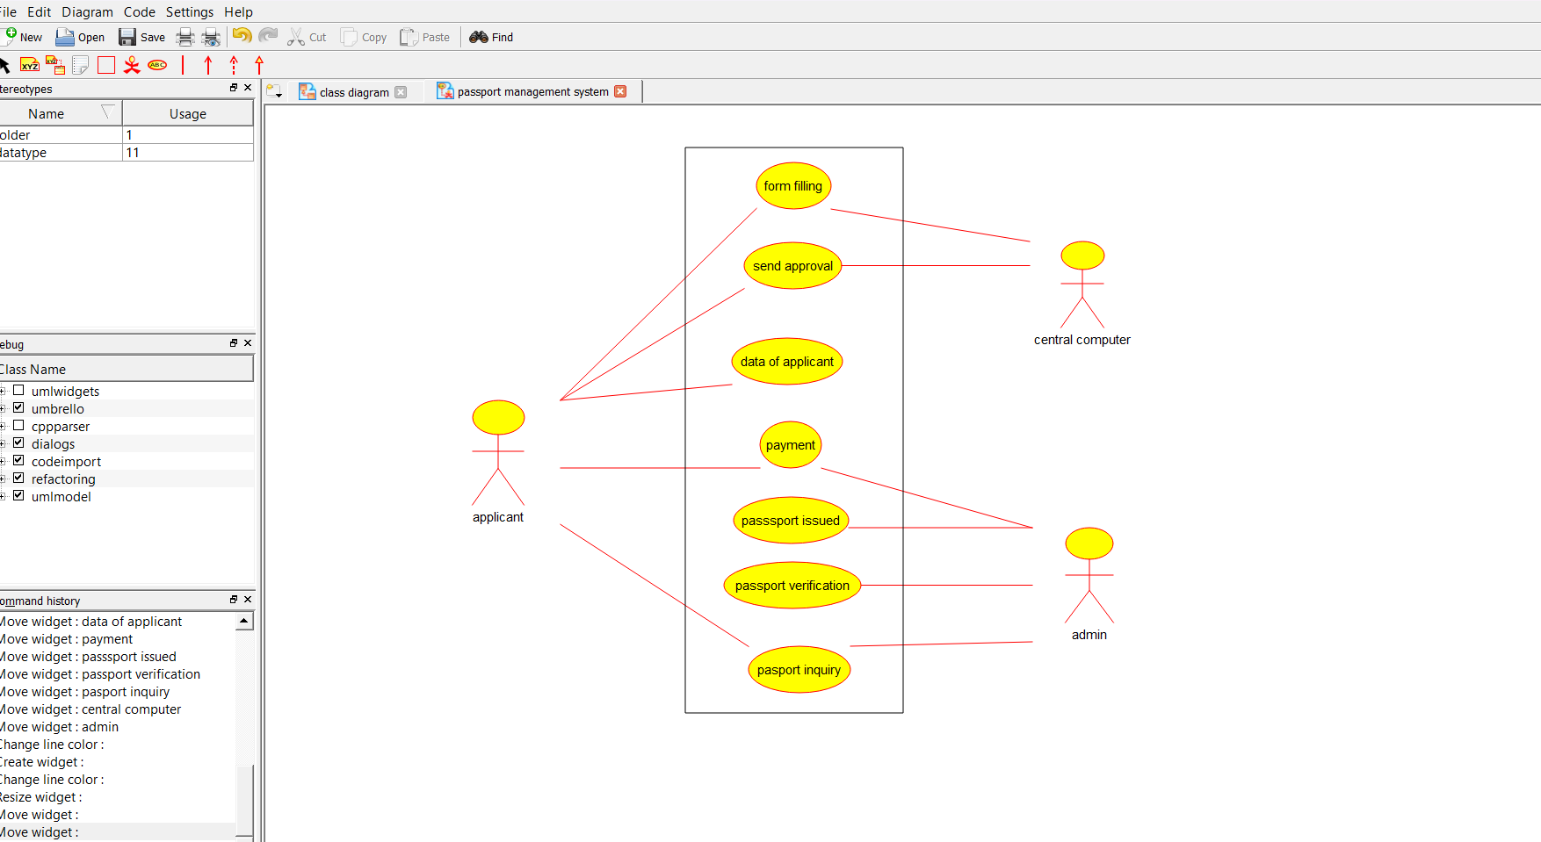

2.CLASS DIAGRAM:

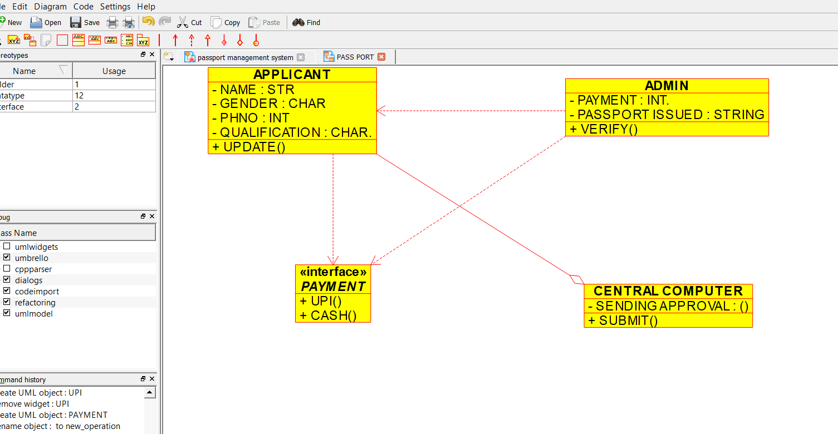

3.SEQUENCE DIAGRAM:

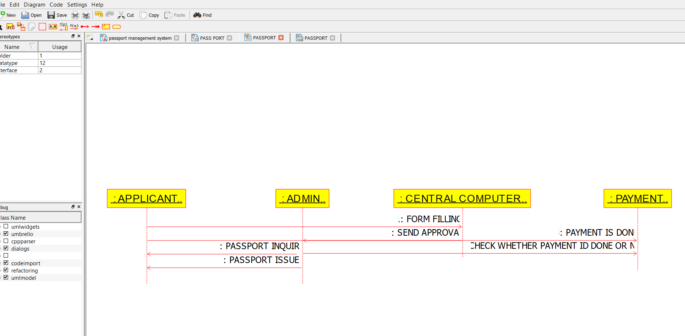

4.PACKAGE DIAGRAM:

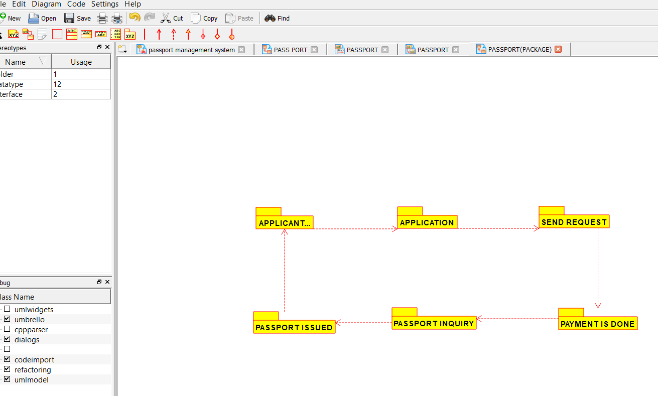

**2.AIM:-**

To develop a system using UML diagrams for BOOK BANK PROCESS.

UML DESIGNS:-

1.USE CASE:

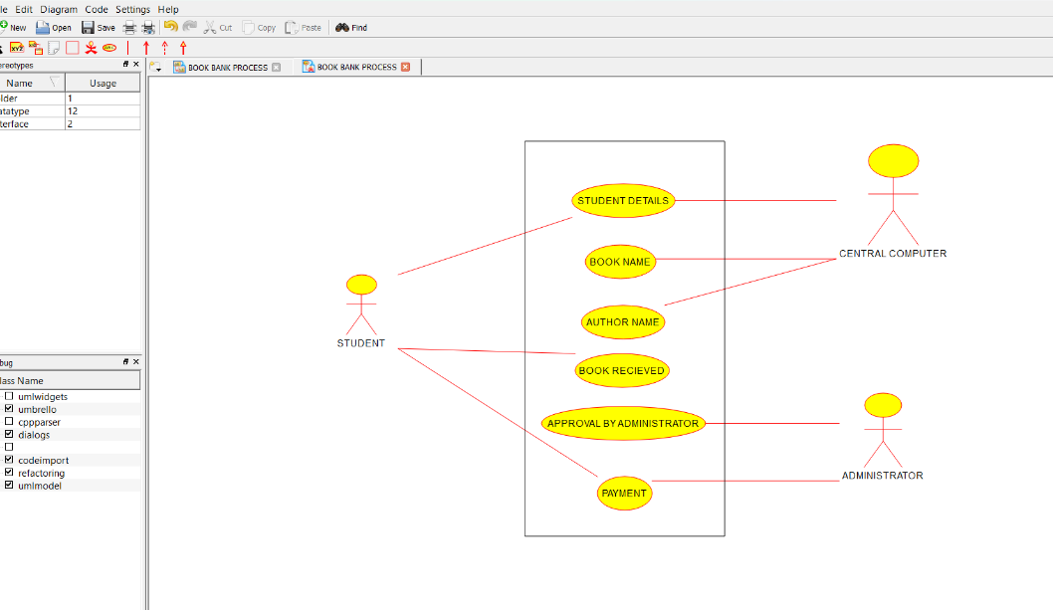

2.COLLABORATION:

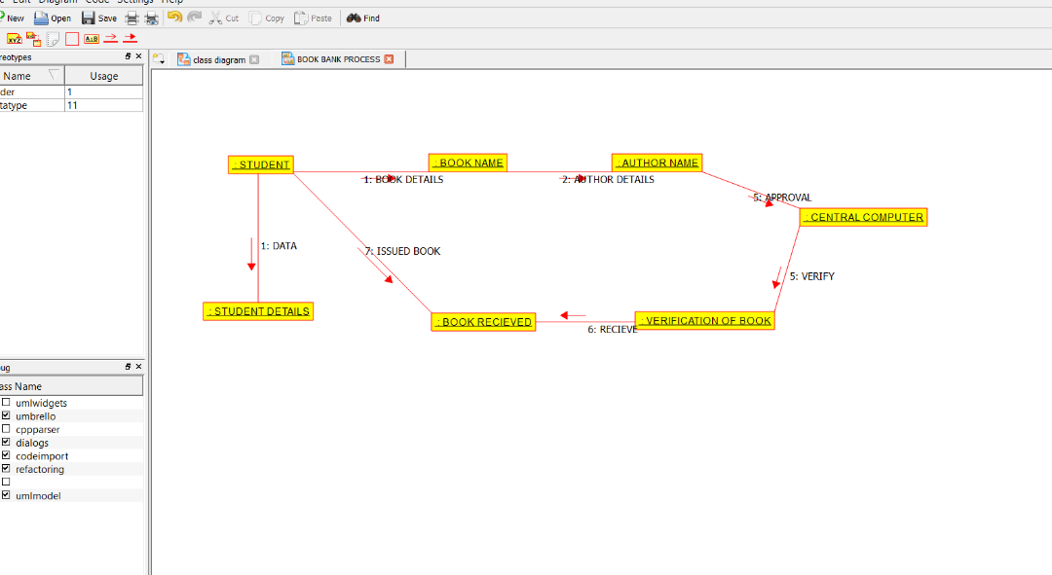

3.DEPLOYMENT DIAGRAM:

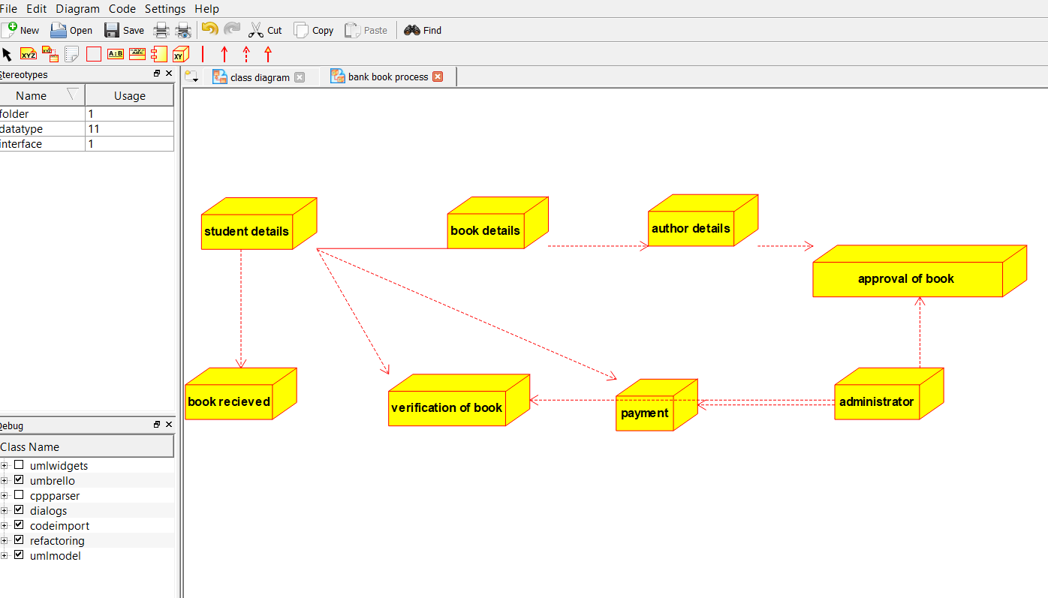

**3.AIM:-**

To develop a system using UML for EXAM REGISTRATION PORTAL.

UML DESIGNS:-

1.COMPONENT:

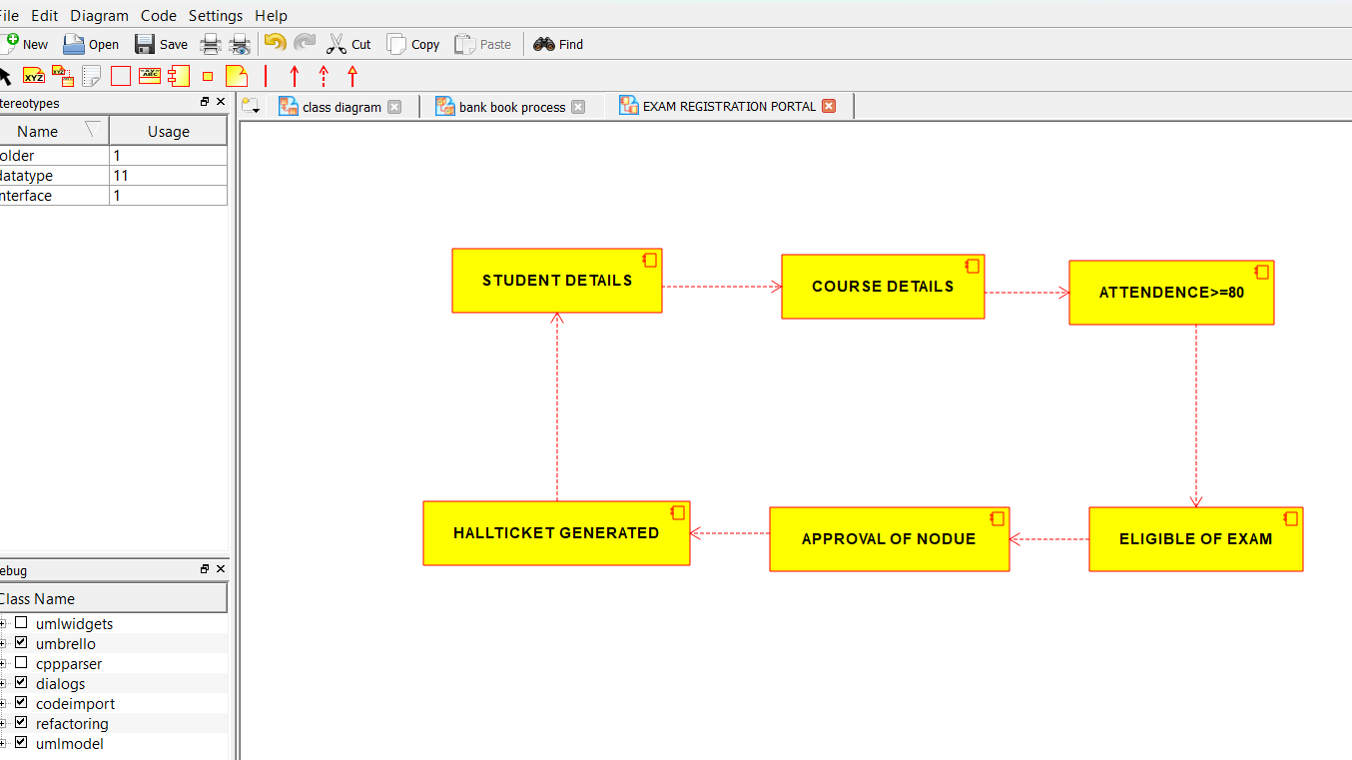

2.PACKAGE DIAGRAM:

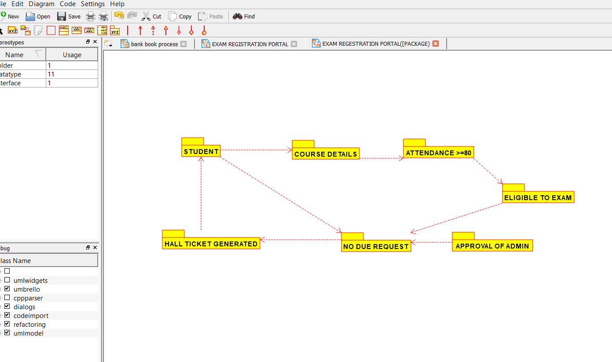

3.USECASE DIAGRAM:

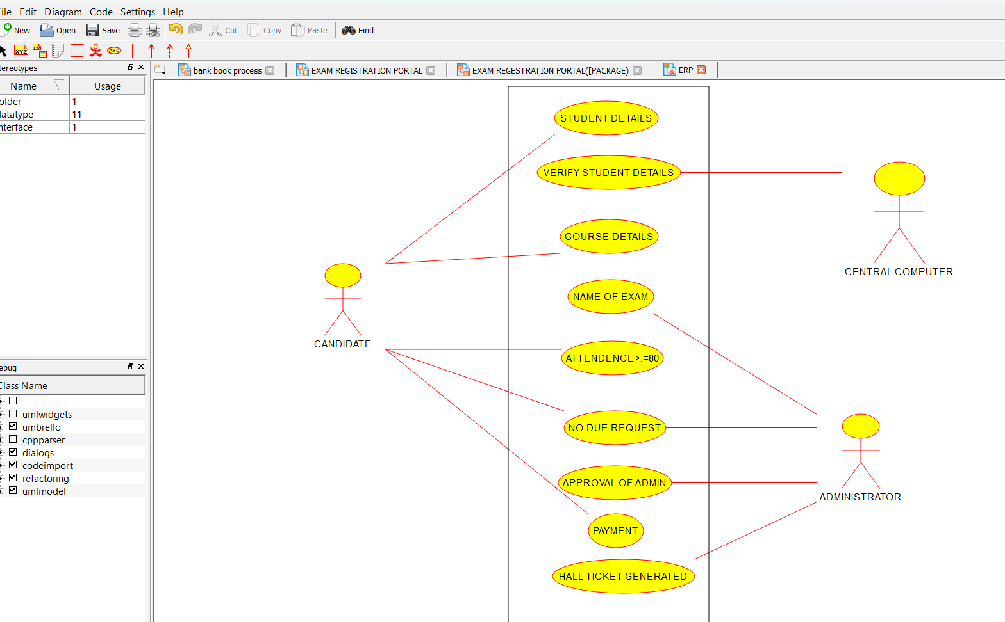

**4.AIM:-**

To develop a system using UML for STOCK MAINTAINANCE SYSTEM.

UML DESIGNS:-

1.STATECHART DIAGRAM:

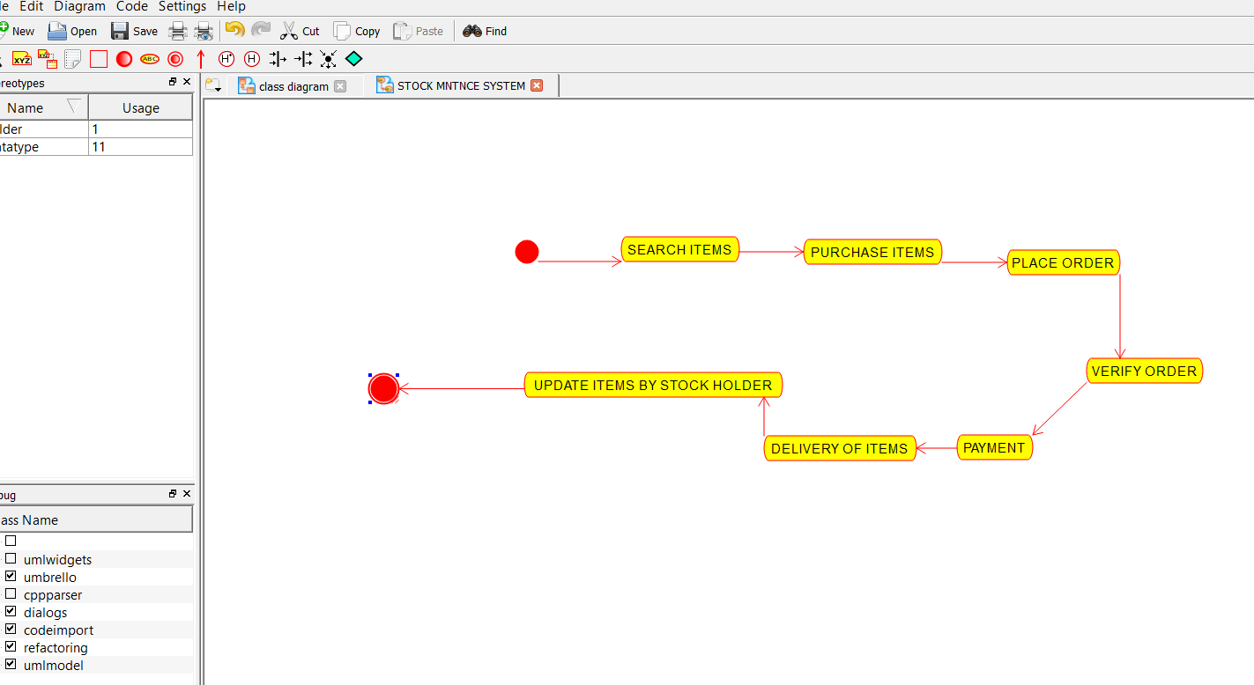

2.DEPLOYMENT:

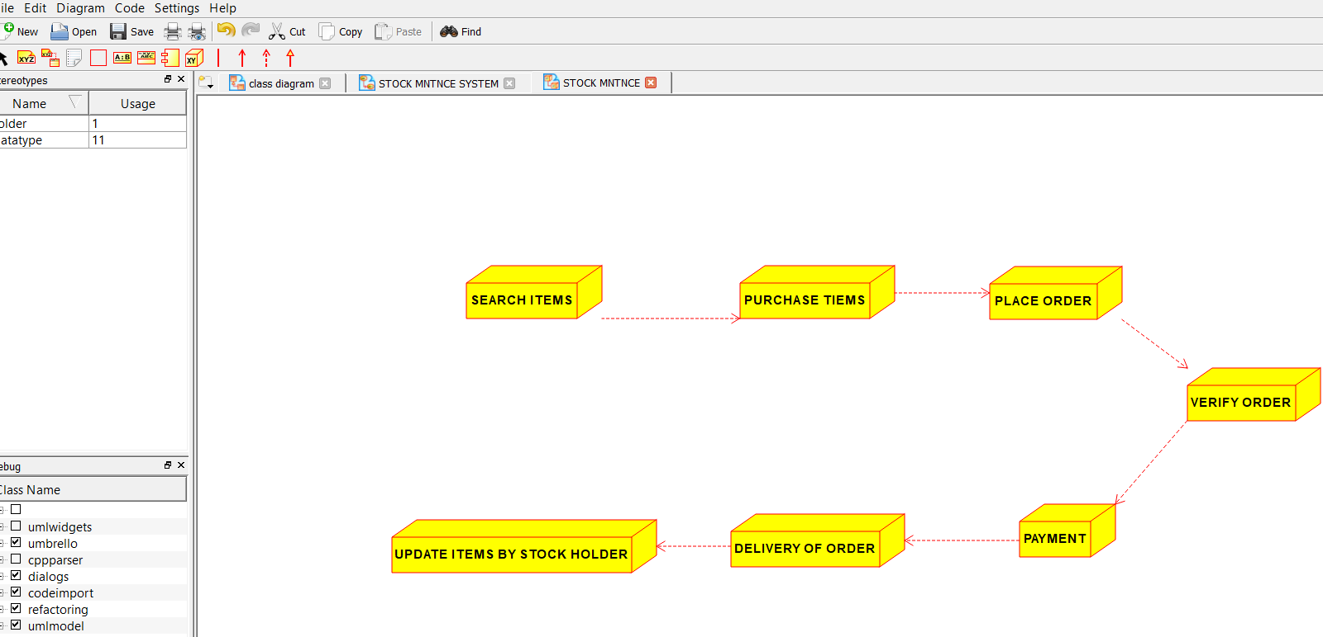

3.PACKAGE DIAGRAM:

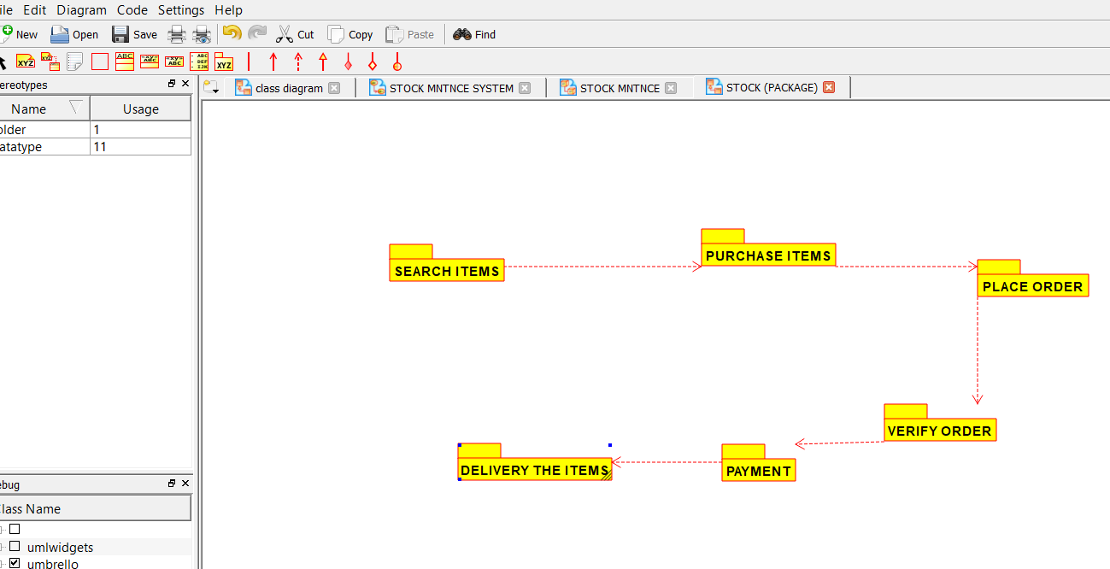

**5.AIM:-**

To develop a system using UML for ONLINE COURSE RESERVATION SYSTEM.

UML DESIGNS:-

1.COLLABORATION:

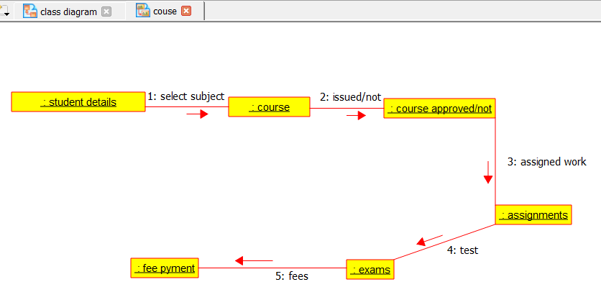

2.USECASE DIAGRAM:

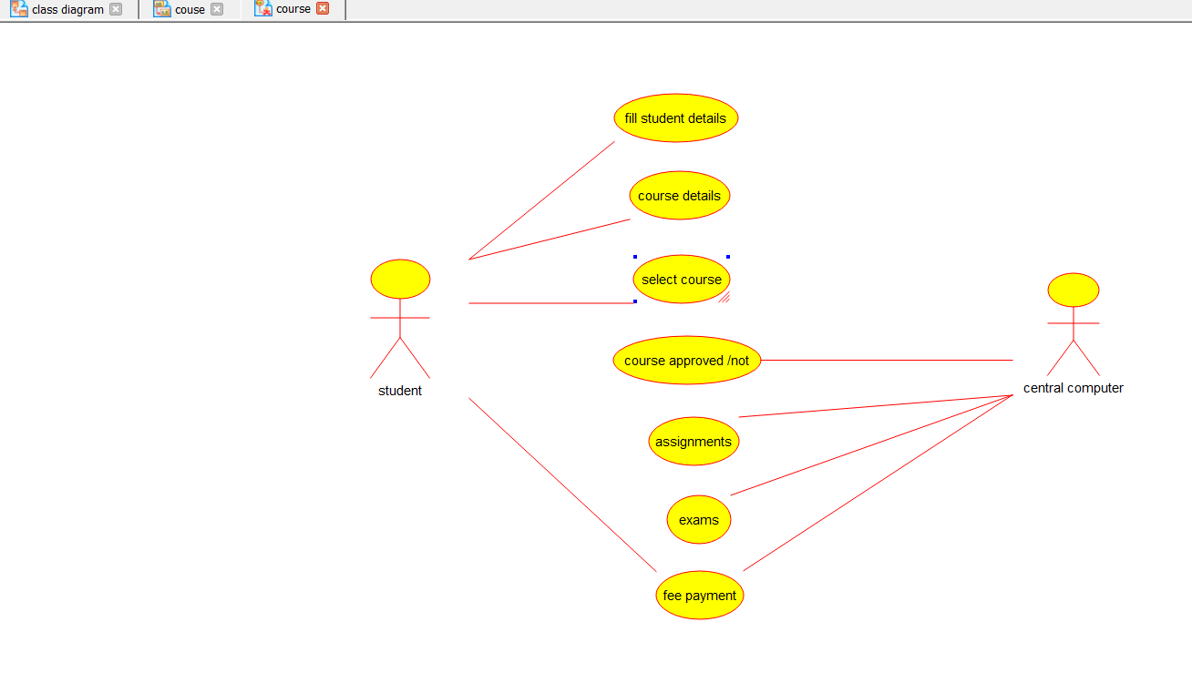

3.ACTIVITY DIAGRAM:

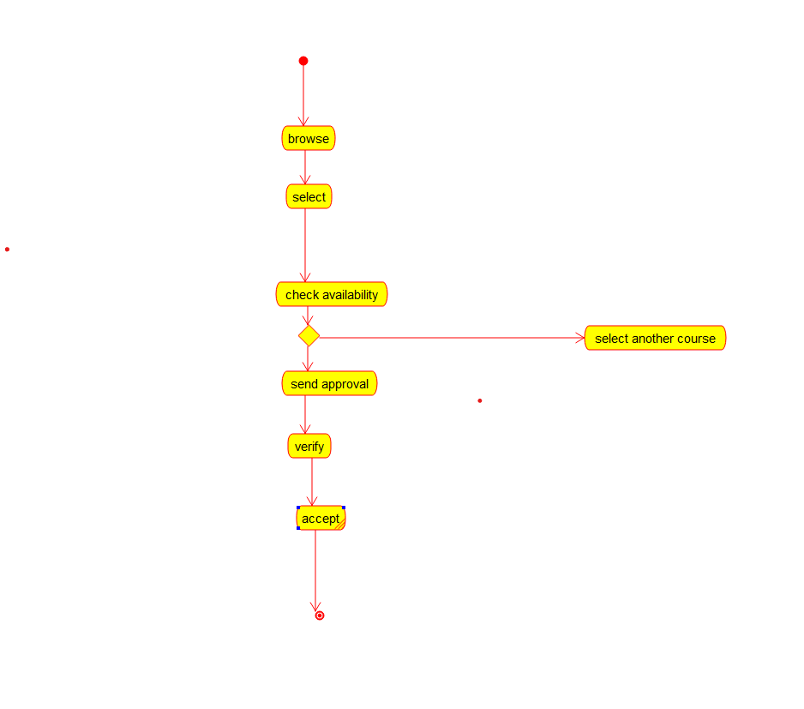

**6.AIM:-**

To develop a system using UML for E-TICKETING SYSTEM.

UML DESIGNS:-

1.ACTIVITY DIAGRAM:

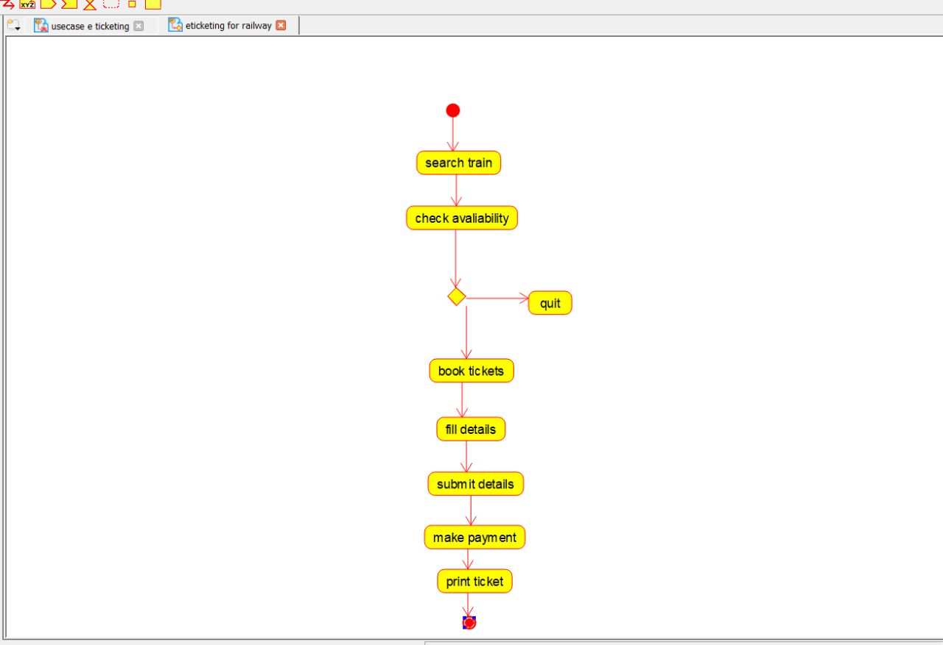

2.USECASE DIAGRAM: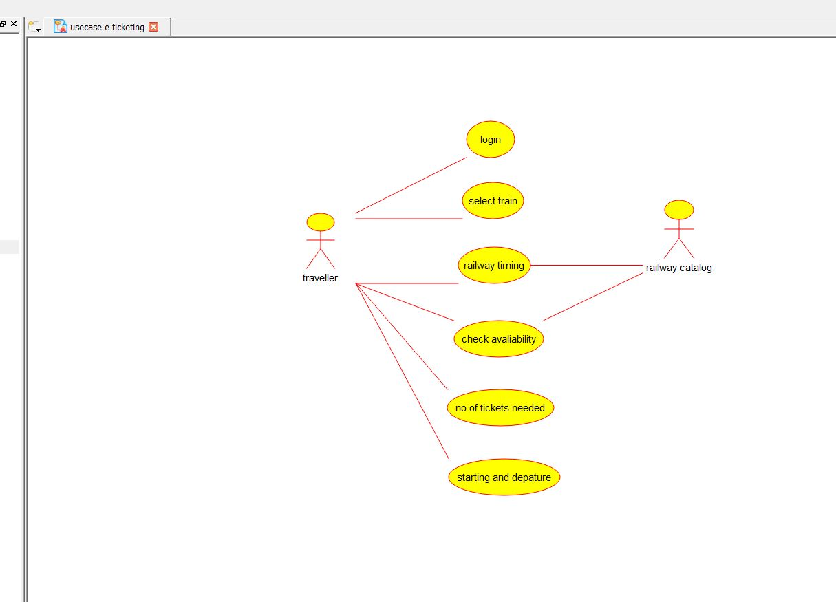

3.COMPONENT DIAGRAM:

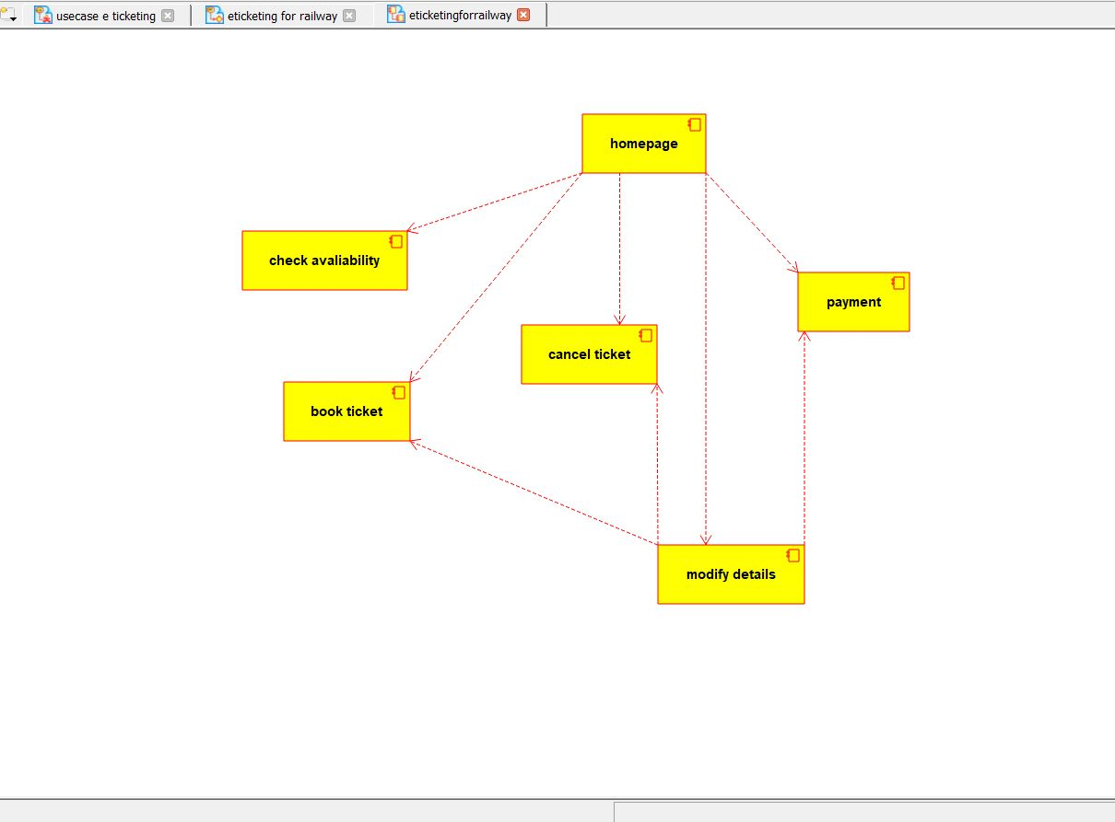

**7.AIM:-**

To develop a system using UML for CREDIT CARD PROCESSING SYSTEM.

UML DESIGNS:-

1.ACTIVITY DIAGRAM:

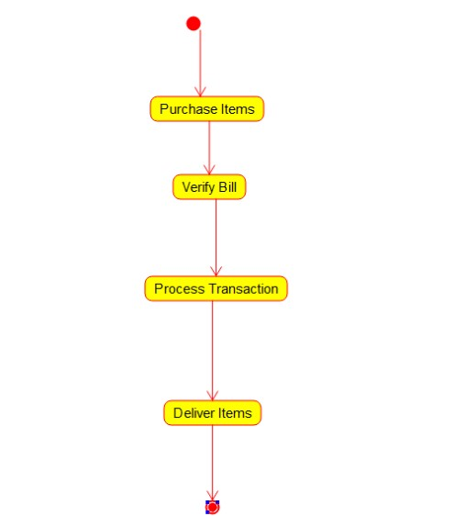

2.CLASS DIAGRAM:

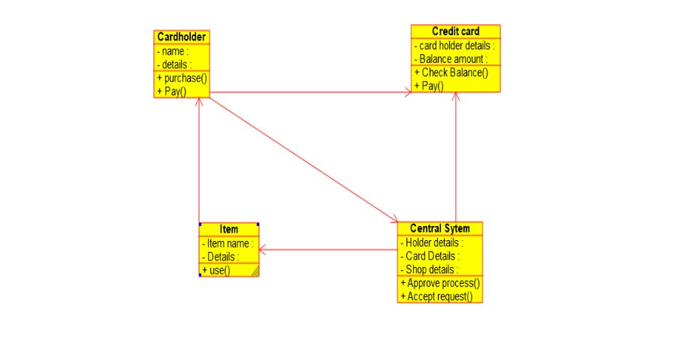

3.COMPONENT DIAGRAM:

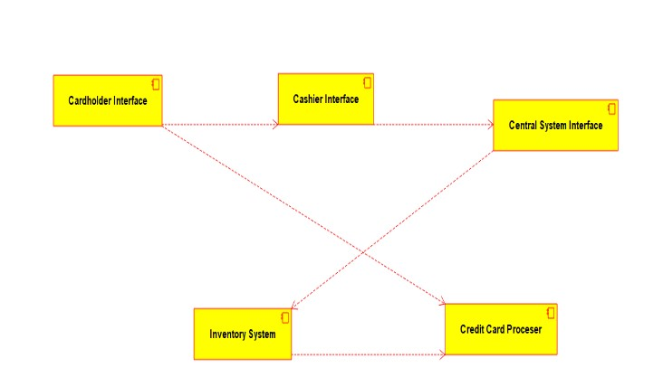

**8.AIM:-**

To develop a system using UML for Software Personnel Management SYSTEM.

UML DESIGNS:-

1.COLLABORATION DIAGRAM:

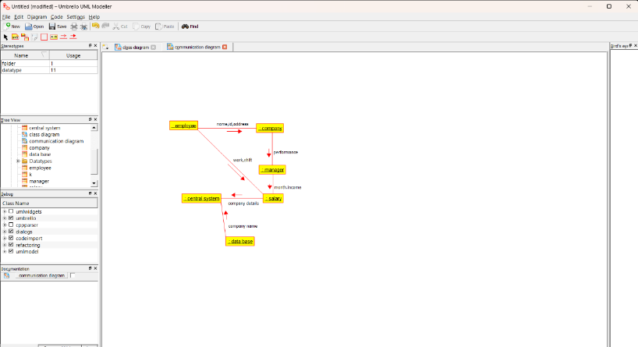

2.COMPONENT DIAGRAM:

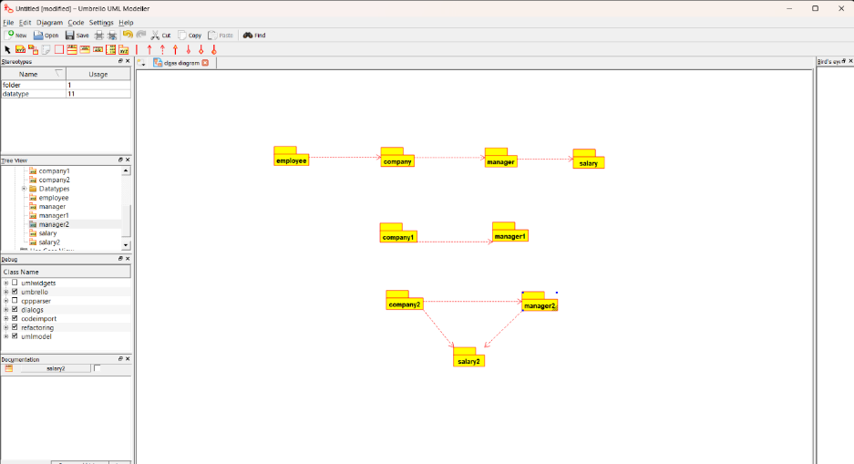

3.USECASE DIAGRAM:

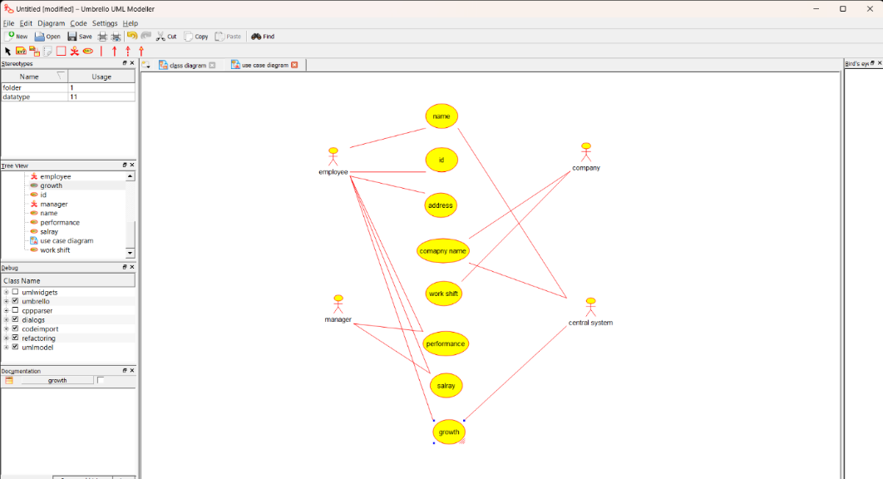

**9.AIM:-**

To develop a system using UML for E-BOOK MANAGEMENT SYSTEM.

UML DESIGNS:-

1.USECASE DIAGRAM:

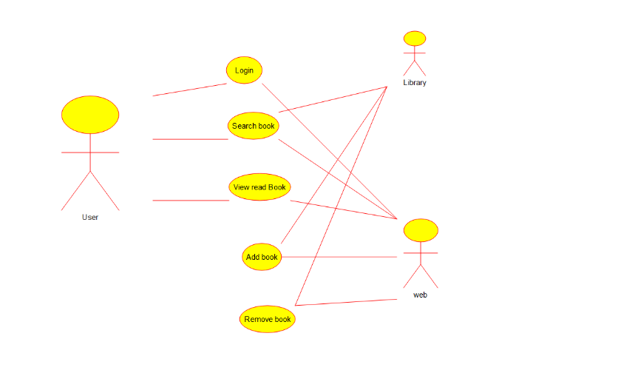

2.CLASS DIAGRAM:

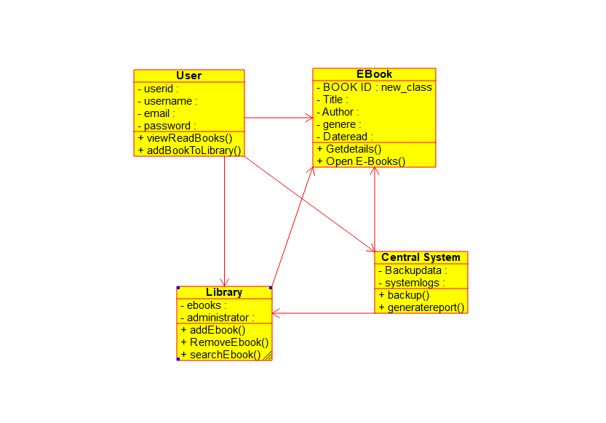

3.ACTIVITY DIAGRAM:

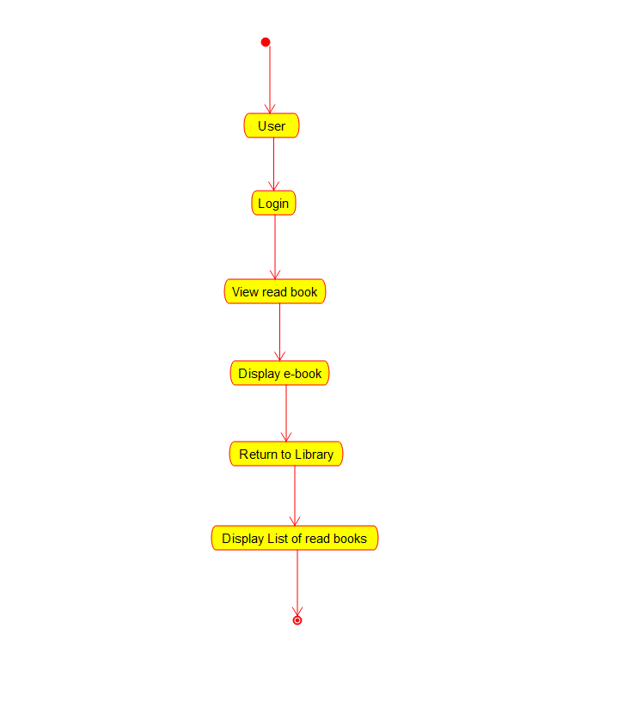

**10.AIM:-**

To develop a system using UML for RECRUITMENT SYSTEM.

UML DESIGNS:-

1.PAKAGE DIAGRAM:

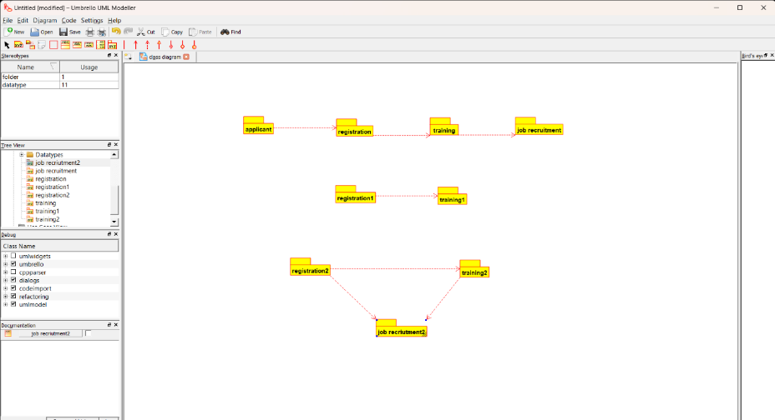

2.DEPLOYMENT DIAGRAM:

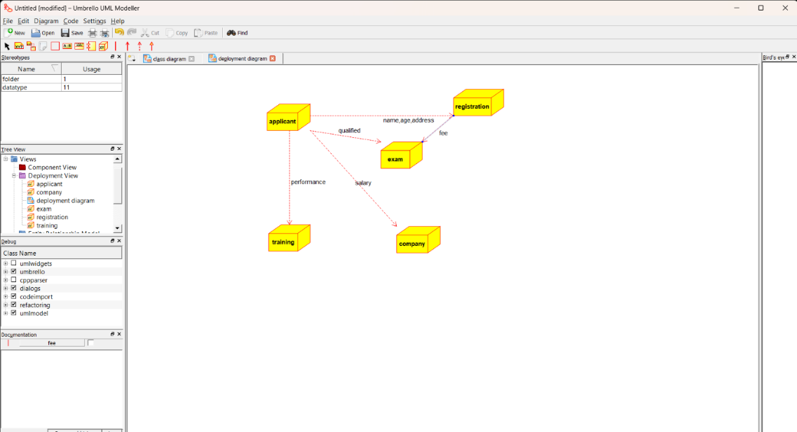

3.SEQUENCE DIAGRAM:

